**TITLE OF PROJECT REPORT**

# A REPORT ON PROJECT BASED LEARNING (SEMESTER -II)

*Submitted by*

DHRUVIN MISTRY – 10905

GHANASHYAM PATIL – 10915

SHRINESH KAMBLE – 10919

SANKET JHAVAR – 10920

# FIRST YEAR ENGINEERING

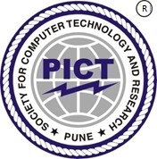

## Society for Computer Technology and Research’s

PUNE INSTITUTE OF COMPUTER TECHNOLOGY

## DHANKAWADI, PUNE – 43

## A.Y. 2020-21

# - CERTIFICATE-

This is to certify that the work incorporated in the report entitled **“RECYCLING, REDUCE AND REUSE OF PLASTIC WASTE”,** is carried out by JHAVAR SANKET GANESH - 10920, who is part a group of students with Project Id 3A92021 under the subject Project ***Based Learning during*** A.Y. 2020-2021.

Such material has not been submitted to any other University/ Institute for any financial support. The literature related to the problem investigated has been appropriately cited and duly acknowledged wherever facilities and suggestions have been availed of.

## Date: Name & Sign of Project Guide

**Place:** PUNE

## Name & Sign of PBL Coordinator Name & Sign of Head of Department

**Dr. A.M. Deshmukh Prof. E. M. Reddy**

**Abstract**

We, the members of Group 3 of FE 9 division, A9 batch have made a project on the topic, “Recycling and Reuse of Plastic Waste”. In this project, we intend to bring forward information about some unique case studies and some amazing organizations that work in recycling, reusing, and reducing plastic waste which provides us with such quality products in place of plastic or using plastic.

This information needs to be out in public and not local areas. This was done by making a website where we have presented brief information on many case studies and organizations. Apart from that, we have also provided information on different types of plastics and the effects of plastic on various elements of the environment. For making the website, each of us had to learn various languages required for the same.

We learned HTML5, CSS, and JavaScript and we have made use of each language in our project. In the end, all the information was checked, revised, and sorted beautifully on our website. Lastly, we have made a tab writing about us. We have tried our best to learn and make this website as informative and responsive as possible, delivering very useful content.

**ACKNOWLEDGEMENT**

This informative website could not have been possible because of the support of esteemed faculties of Pune Institute of Computer Technology. Special thanks to “Dr.A.M Deshmukh” for his guidance and suggestions that helped us improve on our skills and ultimately improve our content and design of our website.

We would like to extend our gratitude to Sir P.T. Kulkarni, Director, Pune Institute of Computer Technology for his constant guidance and providing very nice platform to team.

Lastly, we would like to thank our fellow batchmates who helped us through the web designing process.

DATE: 11/07/2021 GROUP: 3A92021

Place: PUNE Name of Student (in Capital) & Sign

# TABLE OF CONTENT

|  |  |  |
| --- | --- | --- |
| **Chapter No.** | **Title** | **Page No.** |
| 1) | Introduction |  |
| 2) | Work report |  |
| 3) | Conclusions and Learnings |  |

**INTRODUCTION**

Plastic pollution is the accumulation of plastic objects and particles (e.g., plastic bottles, bags and microbeads) in the Earth's environment that adversely affects wildlife, wildlife habitat, and humans. Plastics that act as pollutants are categorized into micro-, meso-, or macro debris, based on size. Plastics are inexpensive and durable making them very adaptable for different uses; as a result, levels human produce a lot of plastic. However, the chemical structure of most plastics renders them resistant to many natural processes of degradation and as a result they are slow to degrade Together, these two factors allow large volumes of plastic to enter the environment as mismanaged waste and for it to persist in the ecosystem.

We divided our project on this topic in three parts:

1. What are the effects of plastic to our environment?
2. Organizations that work towards making our world Plastic Free
3. Some unique Case Studies that displays reduce, recycle and reuse of plastics.

**Chapter 1: How is this project useful?**

We live in world of startups, where new and innovative ideas keep on emerging every day. Many of these ideas are unheard of and they remain localized. With this project we highlight their success and achievements.

Make people aware of such wonderful case studies so that they get inspired to solve many environmental issues like air pollution, increases vehicles, global warming, and many more.

Providing with the information of organizations working towards plastic recycling and reusing.

Can be a starting fuel for many to work towards a Plastic-Free world and make many more inventions and start many businesses for the same.

**Work Report**

**Chapter 1: Content and Learning**

We divided our web page into 4 tabs namely Home, Organizations, Case Studies and About Us. These four tabs have their own functions.

Content on the web page was taking from various sources:

1)www.thehindu.com

2)[www.indianeagle.com](http://www.indianeagle.com)

3)thelogicalindian.com

4)[www.thebetterindia.com](http://www.thebetterindia.com)

5)[www.wikipedia.com](http://www.wikipedia.com)

6)www.unep.org

7)[www.britanicca.com](http://www.britanicca.com)

and many more sources

We combined the data from various websites and made the final content ready.

**We all were naïve in Web Development and had to learn quite a lot to produce the final website. So we used the following sources for leaning of web development:**

**Apni Kaksha (Youtube)**

**Codewithharry (Youtube)**

**W3school (Web platform)**

**Chapter 2: Tabs**

As mentioned above, four tabs were made for the website.

**HOME:**

Home tab consisted of all the ill effects of plastics that affects the environment and human life. Here is an overview of the content on the home tab.

**Plastic-Waste in Sea**

Plastic waste entering the seas is increasing each year with much of the plastic entering the seas is in particles smaller than 5 millimetres.  
  
As of 2016 it was estimated that there was approximately 150 million tonnes of plastic pollution in the world's oceans, estimated to grow to 250 million tonnes in 2025. Another study estimated that in 2012, it was approximately 165 million tonnes.  In 2020 a study found that the Atlantic Ocean contain approximately 10 times more plastic than was previously thought.  The largest single type of plastic pollution (~10 %) and majority of large plastic in the oceans is discarded and lost nets from the fishing industry.

**Plastic-Waste on Land**

Plastic pollution on land poses a threat to the plants and animals – including humans who are based on the land.  
  
 Estimates of the amount of plastic concentration on land are between four and twenty-three times that of the ocean. The amount of plastic poised on the land is greater and more concentrated than that in the water.

**Plastic-Waste in Tap-Water**

A 2017 study found that 83% of tap water samples taken around the world contained plastic pollutants.  This was the first study to focus on global drinking water pollution with plastics, and showed that with a contamination rate of 94%, tap water in the United States was the most polluted, followed by Lebanon and India. European countries such as the United Kingdom, Germany and France had the lowest contamination rate, though still as high as 72%.

However, plastic tap water pollution remains under-studied, as are the links of how pollution transfers between humans, air, water, and soil.

**Effect Of Plastic on Human-beings**

Microplastics entering the human body via direct exposures through ingestion or inhalation can lead to an array of health impacts, including inflammation, genotoxicity, oxidative stress, apoptosis, and necrosis, which are linked to an array of negative health outcomes including cancer, cardiovascular diseases, inflammatory bowel disease, diabetes, rheumatoid arthritis, chronic inflammation, auto-immune conditions, neuro-degenerative diseases, and stroke.

**Organizations:**

We focused on four popular and efficient plastic unfriendly organizations who have put in tremendous efforts to save the world from plastics.

**These organizations are:**

1. **Sahas Zero Waste**
2. **Paperman**
3. **Skrap**
4. **Plastics for Change**

**(“Additional information could be found on our website”)**

**Case Studies:**

This is the heart of our website. Our main aim was to bring these case studies which were localized to public so that they can learn from them and innovate their own ideas.

We basically have 6 Case studies:

1. Ragi Spoons :

Imagine you are on a field trip. You find a wonderful place under a tree to have lunch. The view is beautiful. There is a lake nearby and you can hear birds chirping. You take out the paper dished and plastic spoons to eat the lunch. After you are done eating the delicacies you brought with you. You wrap up the paper dishes and spoon and put them in a plastic bag, and search for a dustbin nearby. But you don’t find any nearby. It might be one option to take the bag with you while you search for the dustbin. Well, Narayana Peesapaty just solved this problem by creating EDIBLE CUTLERY.

1. PPE Masks Bricks:

Binish Desai, ***India’s ‘Recycle Man’*,** makes bricks from discarded face masks Binish Desai’s latest invention — Brick 2.0 — comes at a time when the plastic crisis has snowballed the world over. The ‘Recycle Man of India’, who shot to fame in 2010 for designing P-Block (bricks from industrial paper and gum waste), spent the last few months working on converting discarded face-masks into bricks and is now gearing up for commercial production.

1. Coconut Shell Bowls:

Have you ever eaten a coconut? Of course, you have. But what part of coconut do you eat? Of course, the white part, and then you throw the shell of coconut away!  
  
This is a brilliant way for restaurants and eateries over the globe to eliminate the use of plastic bowls/China made bowls and start using this very organic products.

1. Plastic Made Roads:

A plastic sack manufacturer in Bangalore has managed to find the ideal solution to the ever-increasing problem of accumulating plastic waste.  
  
Ahmed Khan, aged 57 years old, has been producing plastic sacks for 20 years. About 8 years ago, he realized that plastic waste was a real problem. ***Polyblend***, a fine powder of recycled modified plastic, was developed then by his company. This mixture is mixed with the bitumen that is used to lay roads.

**The 5th and 6th case studies are of two plastic unfriendly hotels ( Hotel Andaluz and The Grey Plume). They have minimized the use of plastic and make sure that it remains the same way. More information on them can be found on our website.**

**Chapter 3: CODE**

**Here are the snippets code that we used for making this website:**

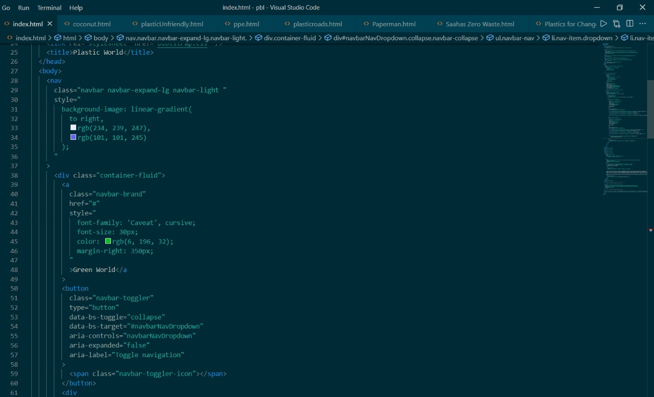

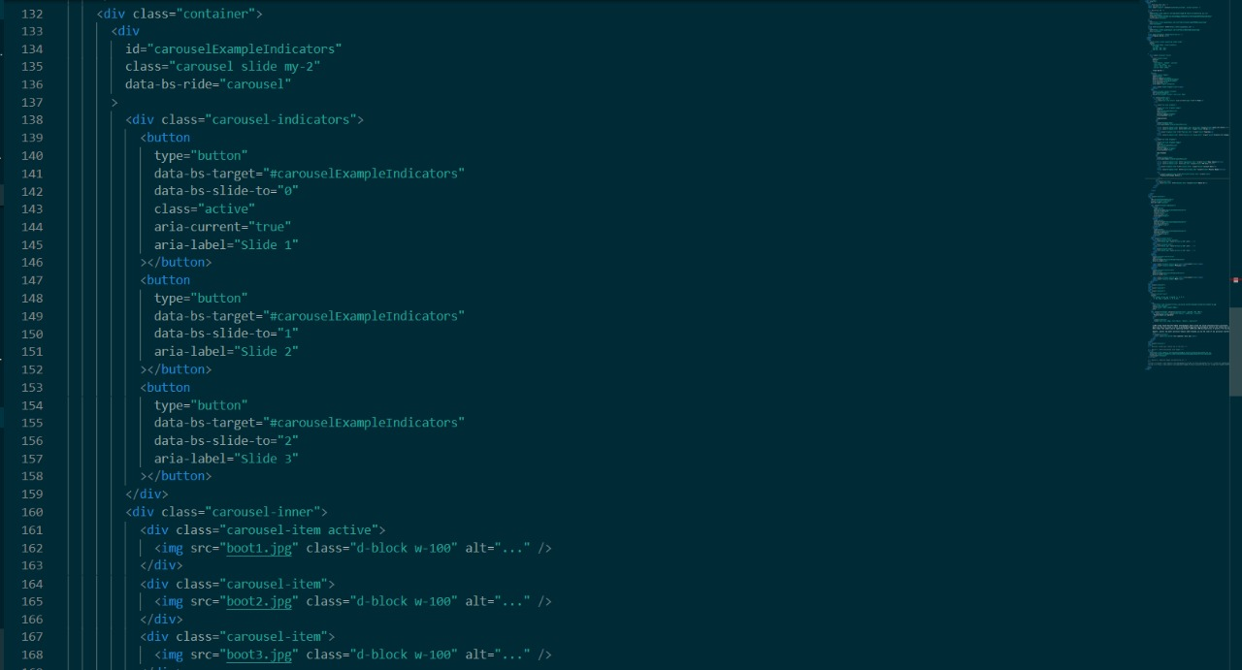

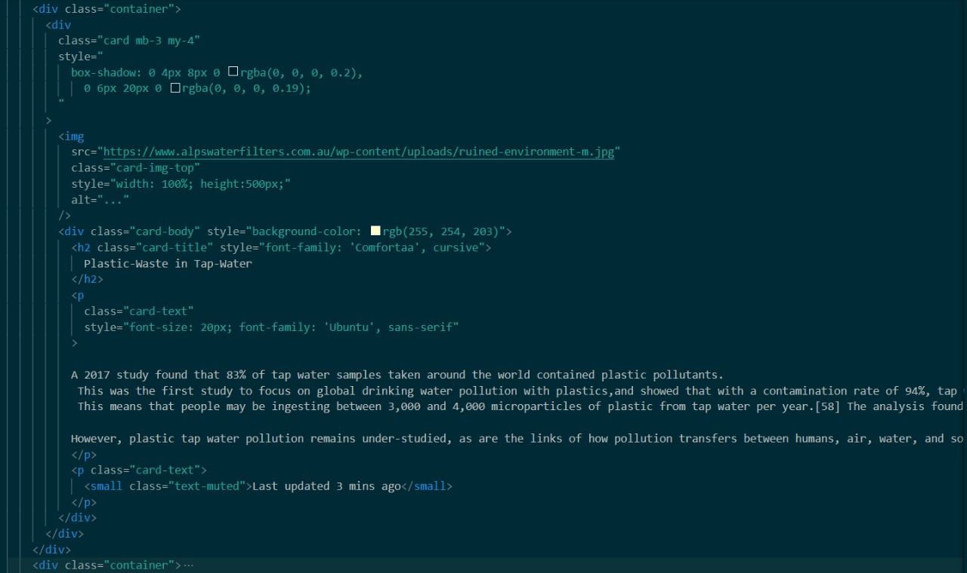

**CONCLUSIONS AND LEARNINGS**

It was immense pleasure to work as a team and make a project. We learned many things from this. Leanings included academic as well as personal growth.

1. All of us were naïve in this field of making websites. So we learnt quite a lot about how webpages are made, how websites are hosted, how do we link webpages to make a website.
2. We learnt 3 languages – HTML5, CSS and JAVASCRIPT. These were the essential languages in making of a website.
3. We explored on the topic of Plastic Waste and how it is recycled.
4. We even found out many unique case studies and organization which we will remember for a long time.
5. We got inspired by such case studies and we intend to spread this awareness around the globe to reduce the use of plastic as far as possible.

**REFERENCES**

Content and learning source links:

1)www.thehindu.com

2)[www.indianeagle.com](http://www.indianeagle.com)

3)thelogicalindian.com

4)[www.thebetterindia.com](http://www.thebetterindia.com)

5)[www.wikipedia.com](http://www.wikipedia.com)

6)www.unep.org

7)[www.britanicca.com](http://www.britanicca.com)

8) <https://www.youtube.com/channel/UCBwmMxybNva6P_5VmxjzwqA/playlists> (WEB DEV COURSE)

9) <https://www.youtube.com/c/CodeWithHarry/playlists> (WEB DEV COURSE)

10) w3school.com